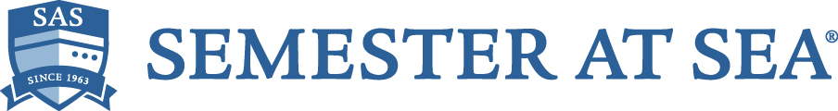

Job Title: Faculty Member – Oceans and Sustainability Specialist
Reports to: Academic Dean
Location: Shipboard

Duration: One voyage (September to December or January to April) plus significant pre-voyage
preparation time

The Institute for Shipboard Education (ISE) seeks faculty candidates for the position of the Oceans and Sustainability (OS) Faculty Specialist for upcoming voyages of Semester at Sea. Semester at Sea (SAS) is a long-established comparative global education program operated by ISE with the collaboration of its academic partner, Colorado State University. The typical semester voyage has a duration of 105 days, visits 8 to 10 countries on multiple continents, and carries around 550 student voyagers plus faculty, staff and others. See www.semesteratsea.org.

The OS Specialist teaches one course in a field such as oceanography or other marine science, ecology and sustainability, or human dimensions of the environment such as environmental economics, environment and politics, or environmental journalism. The course is chosen based on the faculty member’s expertise and student interest. In addition, the OS Specialist is responsible for the Ocean Stewardship and Sustainability component of the required ‘common core’ Global Studies course. The Global Studies course has 4 components: port country cultural orientation and discovery, intercultural competency development, ocean stewardship and sustainability, and a unifying course narrative that offers a coherent message of global learning. The OS Specialist works as part of a team to deliver the overall course, and should be able to deliver content in areas of both marine science and sustainability policy.

The OS Specialist serves as a recognized oceans and sustainability expert during the SAS voyage, with the following responsibilities and expected qualifications.

Responsibilities:
- Teach the Ocean Stewardship and Sustainability component of the Global Studies course, in accordance with established course objectives and program requirements; this course is taught in two sections and will include a full-day Field Class.
- Collaborate with the Global Studies team in delivering the overall course, including organization of readings, other digital resources, exercises, examinations and other assignments, grading duties, etc.
- Teach one additional course decided according to areas of expertise and programmatic needs, bringing the course load to the standard faculty assignment of three.
- Lead two ocean-focused Field Programs as may be suitable to the candidate and to voyage planners.
- Participate by mutual agreement in evening programs on topics relevant to the ocean and the candidate’s additional expertise.
- Fulfill all the general expectations of voyage faculty members; engage in the living-learning community on board the MV World Odyssey.

Qualifications:
- Record of excellence in teaching and scholarship, commensurate with the expectations of all SAS voyage faculty members. See https://www.semesteratsea.org/employment/advice-faculty-staff/
- Background connecting marine science and human dimensions of sustainability (impacts and policy).
- Experience in organizing and teaching large enrollment courses.
- Experience with education abroad, and commitment to global learning.
- Academic expertise and international experience relevant to the voyage itinerary and course objectives.
- Record of effective, collaborative, team leadership.
- Support for the mission of the Institute for Shipboard Education; reflecting ISE values, candidates are expected to have the ability to advance the SAS commitment to diversity and inclusion.
- Availability for pre-voyage planning, orientation activities, and the full duration of the voyage.
- PhD or equivalent terminal degree.

The appointment is for a single voyage at a time. Other terms of employment match the standard voyage faculty terms of appointment. Generally, our faculty members are offered a taxable stipend of $12,000 paid in three equal installments during the voyage. An additional taxable stipend of $1800, in lieu of expense reimbursement, is paid with the first installment.

The acceptance of applications will be ongoing, and selection normally is competed a year or more before the start of the voyage. To apply, send a letter of interest and a current CV to hr@isevoyages.org.

The Institute for Shipboard Education/Semester at Sea is an equal opportunity employer. We encourage anyone, regardless of race, age, creed, color, religion, national origin or ancestry, sex, gender, disability, veteran status, genetic information, sexual orientation, or gender identity or expression, to apply.

